Illustrative Examples of Evaluation Criteria

This supplementary document provides illustrative examples of the 11 evaluation criteria used by both human experts and GPT to grade the UML diagrams created by the students. Either the UML diagrams or the grading reasons are raw data without any adjustment.
- Note 1: In the exemplary UML diagrams, the modeling elements might be named in Chinese, since the UML modeling task is assigned to Chinese students and they are not required to submit the project report in English.
- Note 2: In the examples of 11 evaluation criteria, the reasons given by human experts are written in Chinese.
- Note 3: In the examples of 11 evaluation criteria, the reasons given by GPT might have some Chinese characters if the graded UML diagram is represented with Chinese characters, according to Note 1.
- Evaluation Criterion for UML Use Case Diagram

The exemplary UML use case diagrams are listed as follows.
Use Case Diagram in UML Modeling Report 2  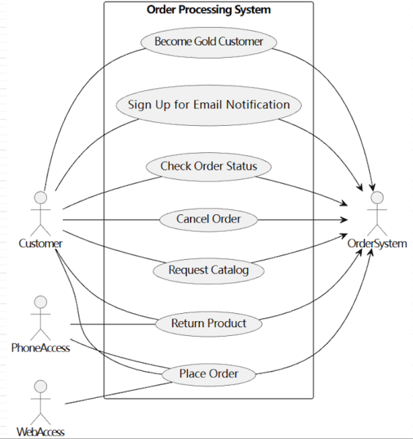 | Use Case Diagram in UML Modeling Report 4  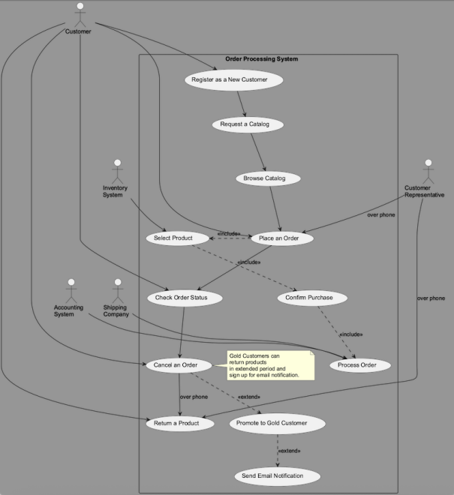
Use Case Diagram in UML Modeling Report 6  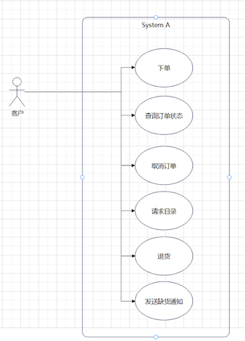 | Use Case Diagram in UML Modeling Report 11  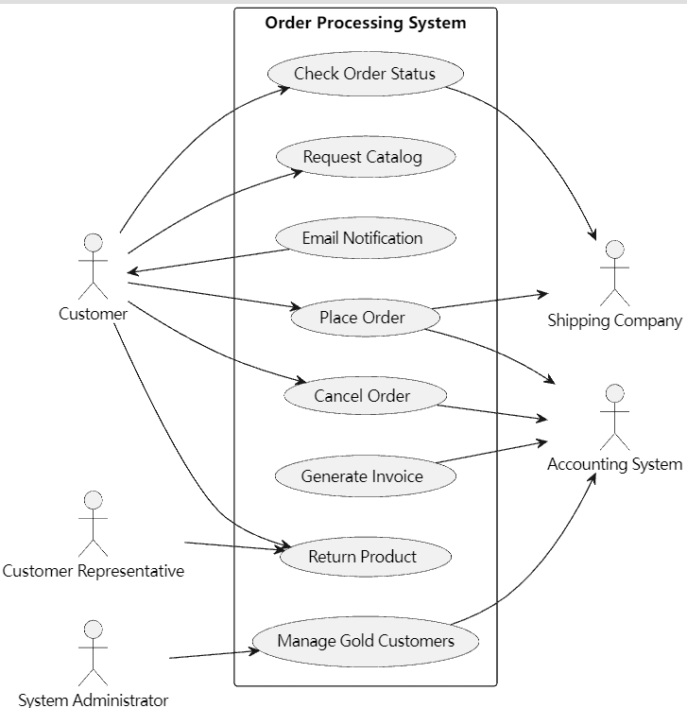
Use Case Diagram in UML Modeling Report 18  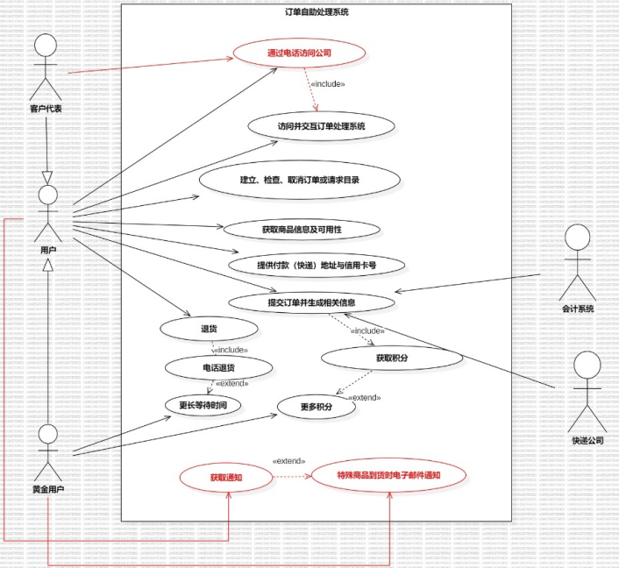 | Use Case Diagram in UML Modeling Report 19  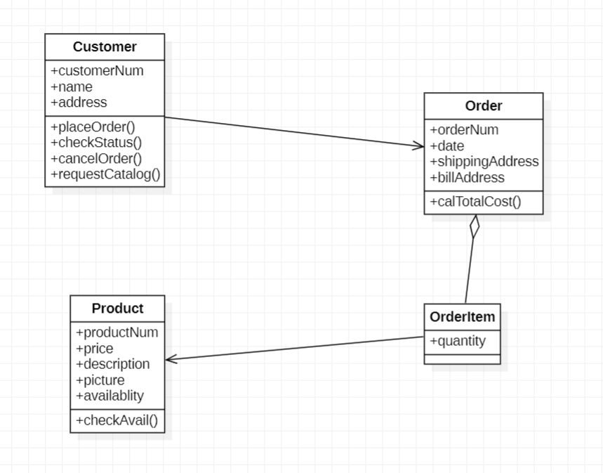
Use Case Diagram in UML Modeling Report 35  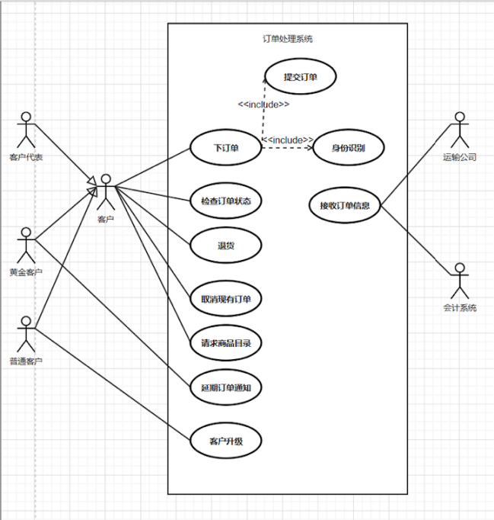 | Use Case Diagram in UML Modeling Report 38  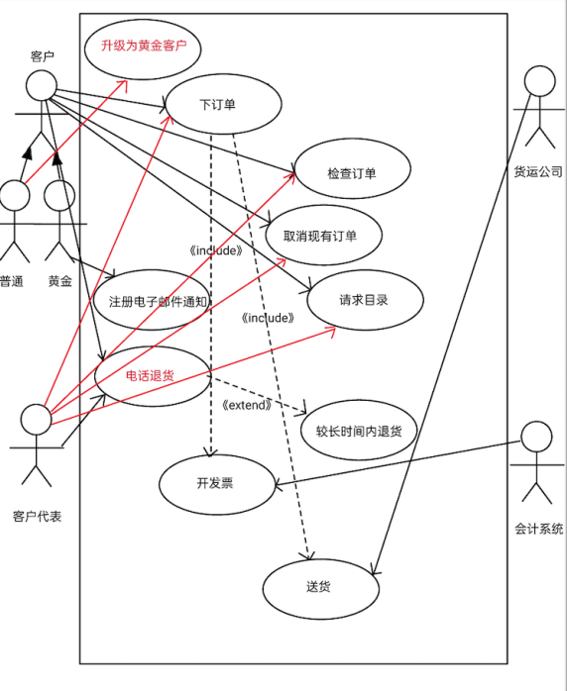

# | Origin of UML diagram | Human Experts (Score)/ GPT(Score): Reasons (deducted points) | Type of discrepancy
UC1 | UML Modeling Report 2 | Human Expert (0.8): 缺少Gold Customer这个核心actor，扣0.2分。(-0.2) | Reasonable Identification
UC1 | UML Modeling Report 2 | GPT (0.4): Missing actor: Gold Customer is not shown as a separate actor (should be a specialization of Customer).(-0.2); Missing actor: Accounting System is not present.(-0.2); Unreasonable actor: OrderSystem is shown as an actor, but it should be the system boundary, not an external actor.(-0.2) | Reasonable Identification
UC1 | UML Modeling Report 4 | Human Expert (0.8): 缺少Gold Customer这个核心actor，扣0.2分。(-0.2) | Wrong Identification
UC1 | UML Modeling Report 4 | GPT (0.6): Missing actor: Gold Customer is not explicitly modeled as an actor (should be a specialization of Customer).(-0.2); Missing actor: Customer Representative is not included (should be present as per the case study and reference).(-0.2) | Wrong Identification
UC1 | UML Modeling Report 18 | Human Expert (1.0): N/A | Misunderstanding
UC1 | UML Modeling Report 18 | GPT (0.6): Customer (the student uses '用户' (User), which is acceptable, but does not show 'Customer Rep' (客户代表) as a separate actor, only as a communication channel).(-0.2); Missing actor: Shipping Company (快递公司), which is present in the reference but not connected to any use case in the student diagram.(-0.2) | Misunderstanding
UC1 | UML Modeling Report 19 | Human Expert (0.8): 缺少Gold Customer核心actor(-0.2) | Perfect Match
UC1 | UML Modeling Report 19 | GPT (0.8): Missing actor: Gold Customer is not included in the use case diagram.(-0.2) | Perfect Match
UC1 | UML Modeling Report 35 | Human Expert (1.0): N/A | Overstrictness
UC1 | UML Modeling Report 35 | GPT (0.8): Missing 'Accounting System' actor, which is a core actor in the system.(-0.2) | Overstrictness
UC2 | UML Modeling Report 4 | Human Expert (1.0): N/A | Overstrictness
UC2 | UML Modeling Report 4 | GPT (0.9): Missing use case: Signup for Notification (not present in the diagram, only mentioned as a note).(-0.1) | Overstrictness
UC2 | UML Modeling Report 11 | Human Expert (0.9): 缺少Signup for Notification(-0.1) | Misunderstanding
UC2 | UML Modeling Report 11 | GPT (0.5): Missing use case: Signup for Notification (Email Notification is present, but not clearly tied to Gold Customer or back order context).(-0.1); Missing use case: Return Product is present, but should be restricted to Customer Representative, not Customer.(-0.0); Unreasonable use case: Generate Invoice is included as a separate use case, but invoicing is a system process, not a user-initiated use case.(-0.2); Unreasonable use case: Manage Gold Customers is included, but this is not a functional requirement for end users or described in the case.(-0.2) | Misunderstanding
UC2 | UML Modeling Report 18 | Human Expert (0.6): 取消订单和查看目录不应该合成一个用例而是拆开(-0.2)；更多积分不应该是一个用例(-0.2) | Wrong Identification
UC2 | UML Modeling Report 18 | GPT (0.7): Missing use case: Cancel Order (no equivalent use case for order cancellation).(-0.2); Missing use case: Signup for Notification (only '获取通知' is present, but not clearly linked as a use case for gold customers for back order notification).(-0.1) | Wrong Identification
UC2 | UML Modeling Report 19 | Human Expert (0.7): 缺少Check Order Status和Signup for Notification用例（-0.3） | Reasonable Identification
UC2 | UML Modeling Report 19 | GPT (0.9): Missing use case: Signup for Notification is not included.(-0.1) | Reasonable Identification
UC2 | UML Modeling Report 35 | Human Expert (0.9): 缺少Signup for Notification(注册到货邮件提醒)用例。(-0.1); | Perfect Match
UC2 | UML Modeling Report 35 | GPT (0.9): Missing use case 'Signup for Notification', which is an essential use case for gold customers.(-0.1) | Perfect Match
UC3 | UML Modeling Report 4 | Human Expert (0): 缺少Gold Customer与Customer之间的泛化(generalization)关系(-1.0) | Perfect Match
UC3 | UML Modeling Report 4 | GPT (0):Missing generalization relationship between Gold Customer and Customer (no inheritance arrow present).(-1.0) | Perfect Match
UC3 | UML Modeling Report 18 | Human Expert (1.0): N/A | Perfect Match
UC3 | UML Modeling Report 18 | GPT (1.0): N/A | Perfect Match
UC3 | UML Modeling Report 35 | Human Expert (1.0): N/A | Wrong Identification
UC3 | UML Modeling Report 35 | GPT (0): Generalization relationship between 'Gold Customer' and 'Customer' is missing; instead, both are shown as separate actors connected to 'Customer', but not as a generalization.(-1.0) | Wrong Identification
UC3 | UML Modeling Report 38 | Human Expert (1.0): N/A | Overstrictness
UC3 | UML Modeling Report 38 | GPT (0):Generalization relationship between Gold Customer and Customer is not shown; instead, '普通' and '黄金' are modeled as separate actors.(-1.0) | Overstrictness
UC4 | UML Modeling Report 2 | Human Expert (0.6): 缺少Gold Customer与Signup for Notification关联。(-0.1); 缺少Customer Rep 与Return Product关联。(-0.1);OrderSytem与Request Catalog、Sign up for Nptification关联不合理，各扣0.1，(-0.2) | Misunderstanding
UC4 | UML Modeling Report 2 | GPT (0.8): Missing necessary relationship: Signup for Notification should be linked to Gold Customer (but Gold Customer is missing).(-0.1); Unnecessary relationship: OrderSystem actor is linked to all use cases, which is not reasonable.(-0.1) | Misunderstanding
UC4 | UML Modeling Report 4 | Human Expert (0.8): 缺少Customer Rep与Return Product关联。(-0.1);缺少Gold customer和Send Email Notification关联。(-0.1) | Perfect Match
UC4 | UML Modeling Report 4 | GPT (0.8): Missing relationship: Customer is not connected to 'Return a Product' (should be via Customer Rep for phone returns).(-0.1); Missing relationship: Gold Customer (if present) should be connected to 'Signup for Notification' (use case is only in a note, not as a use case).(-0.1) | Perfect Match
UC4 | UML Modeling Report 6 | Human Expert (0.8): 缺少Gold Customer和“发送缺货通知”关联 (-0.1)，缺少Customer Rep和“退货”关联 (-0.1) | Overstrictness
UC4 | UML Modeling Report 6 | GPT (0.7): Missing necessary relationships: Gold Customer and Accounting System are not present, so their relationships to relevant use cases are missing.(-0.2); Missing necessary relationship: 'Return Product' should only be available via Customer Rep or Gold Customer, but only 'Customer' is shown.(-0.1) | Overstrictness
UC4 | UML Modeling Report 18 | Human Expert (0.9): 退货’未与‘客户代表’关联 (-0.1) | Wrong Identification
UC4 | UML Modeling Report 18 | GPT (0.8): Missing relationship: Gold Customer is not connected to '获取通知' (Signup for Notification), which is a special right for gold customers.(-0.1); Missing relationship: Accounting System is not connected to any use case (should be linked to order/invoice related use cases).(-0.1) | Wrong Identification
UC4 | UML Modeling Report 19 | Human Expert (0.8): Customer未与Return Product用例关联(-0.2) | Reasonable Identification
UC4 | UML Modeling Report 19 | GPT (0.7): Missing necessary relationship: Gold Customer is not linked to any use cases (since Gold Customer is missing).(-0.1); Unnecessary relationship: Accounting System is linked to 'receive invoice' use case, which is not an actor-initiated use case.(-0.1); Unnecessary relationship: Shipping Company is linked to 'ship order' use case, which is not an actor-initiated use case.(-0.1) | Reasonable Identification

- Evaluation Criterion for UML Class Diagram

The exemplary UMLclass diagrams are listed as follows.
Class Diagram in UML Modeling Report 3  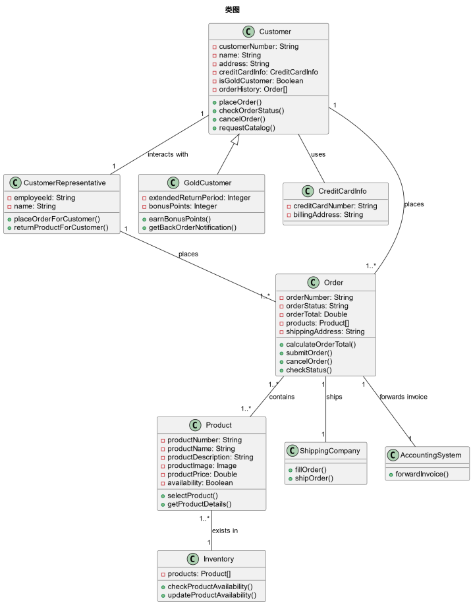 | Class Diagram in UML Modeling Report 6  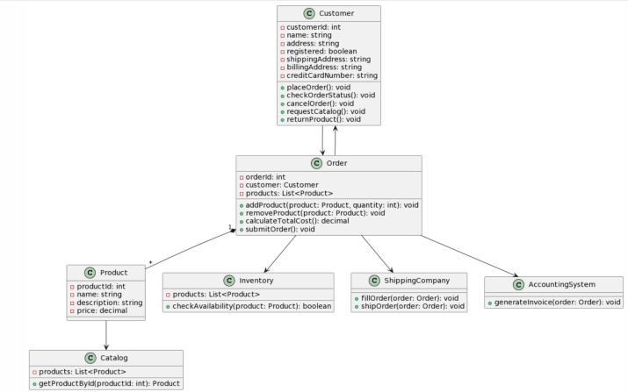
Class Diagram in UML Modeling Report 7  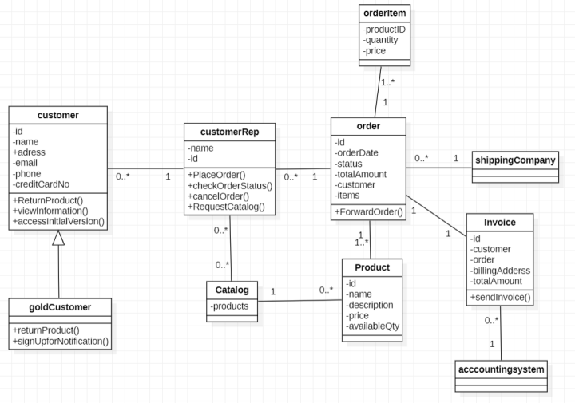 | Class Diagram in UML Modeling Report 11  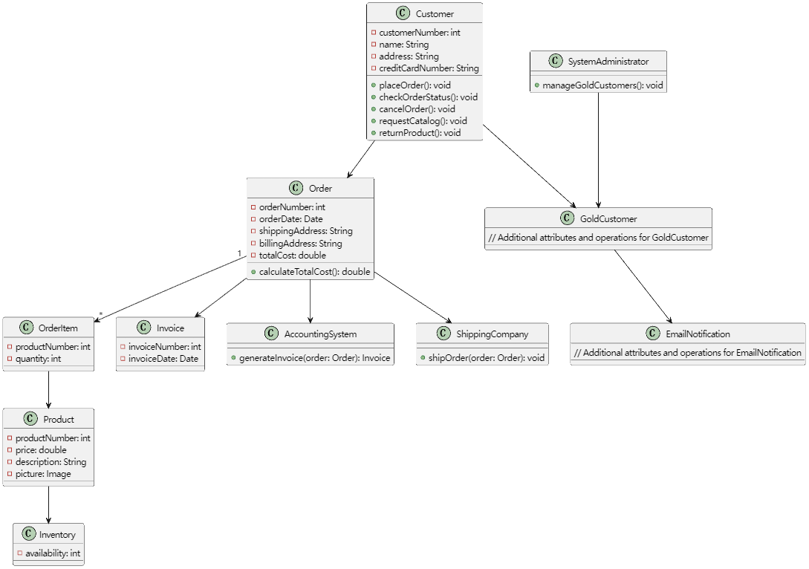
Class Diagram in UML Modeling Report 13  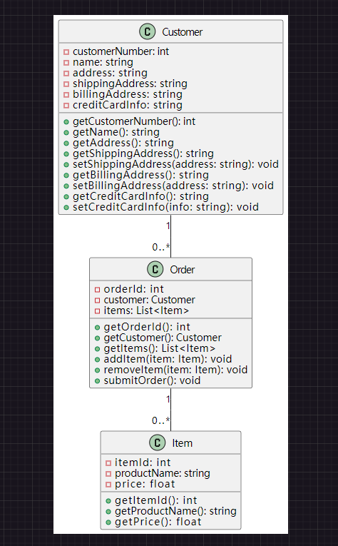 | Class Diagram in UML Modeling Report 21  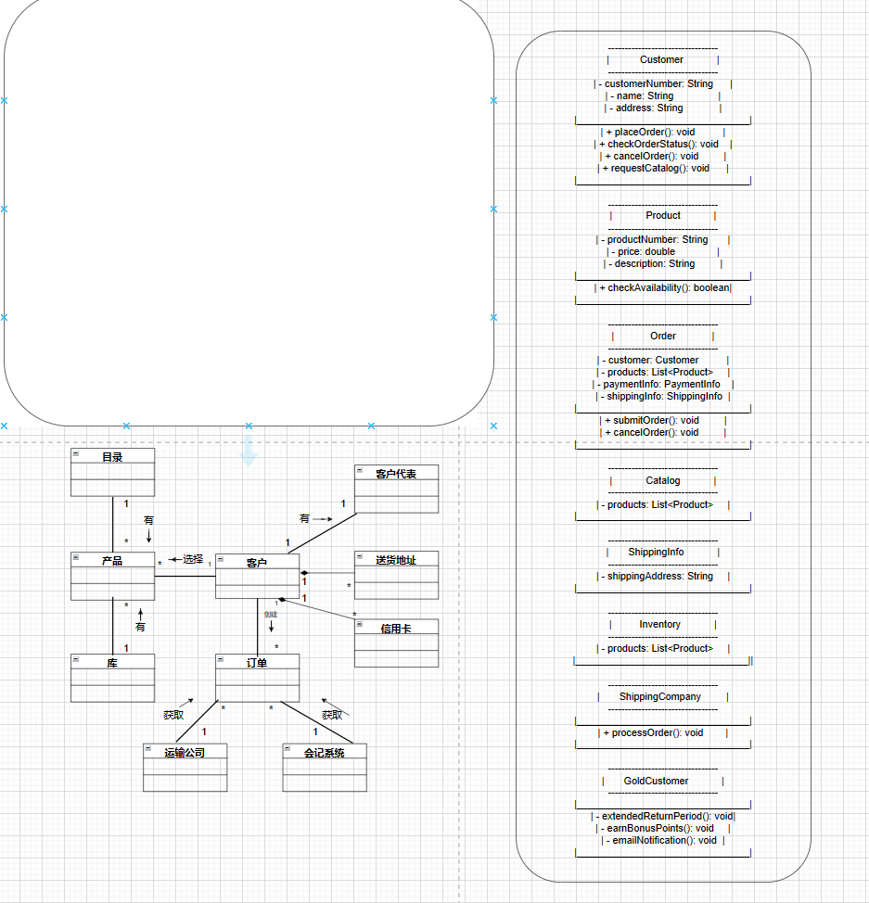
Class Diagram in UML Modeling Report 27  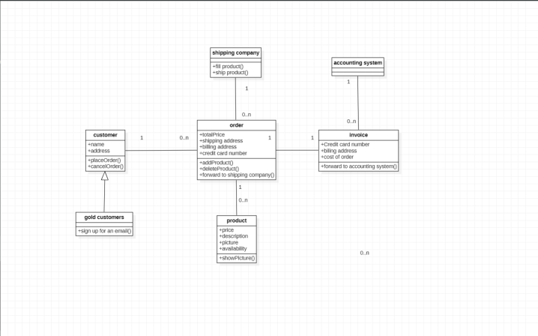 | Class Diagram in UML Modeling Report 29  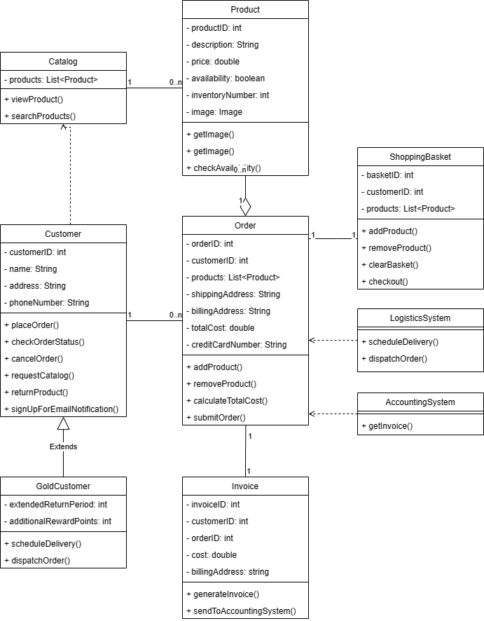
Class Diagram in UML Modeling Report 30  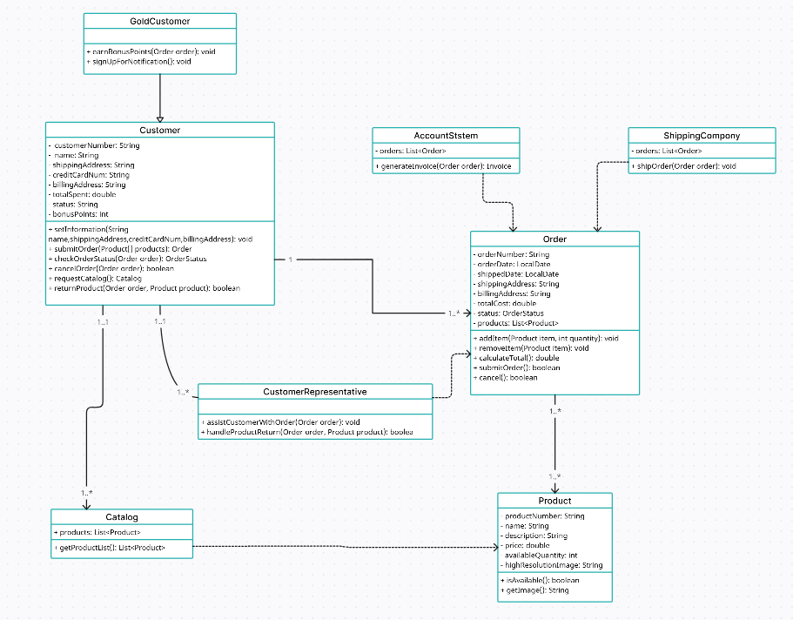 | Class Diagram in UML Modeling Report 33  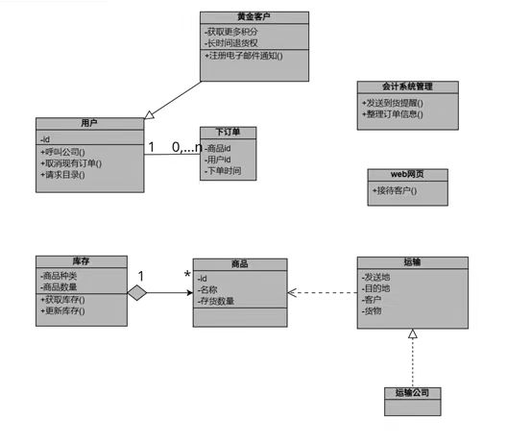

# | Origin of UML diagram | Human Experts (Score)/ GPT(Score) : Reasons (deducted points) | Type of discrepancy
CC1 | UML Modeling Report 7 | Human Expert (0.8): 识别了7个核心类，Customer, GoldCustomer, CutomerRep, Product, Order, Invoice, AccountingSystem,少1个核心类(-0.2) | Misunderstanding
CC1 | UML Modeling Report 7 | GPT (0.4): Missing essential class: BackOrderNotifier (not present), deduct 0.2.(-0.2); Missing essential class: ShippingInfo (not present), deduct 0.2.(-0.2); Missing essential class: OrderProcessingManager (not present), deduct 0.2.(-0.2); Unreasonable class: None detected.(-0.0) | Misunderstanding
CC1 | UML Modeling Report 11 | Human Expert (1.0): N/A | Overstrictness
CC1 | UML Modeling Report 11 | GPT (0.2): Missing essential class: BackOrderNotifier is not included.(-0.2); Missing essential class: ShippingInfo is not included as a separate class (shipping and billing addresses are attributes of Order, but not a class).(-0.2); Missing essential class: OrderProcessingManager is not included.(-0.2); Unreasonable class: SystemAdministrator is included but not relevant to the core domain.(-0.2) | Overstrictness
CC1 | UML Modeling Report 13 | Human Expert (0): 只识别出两个核心类，不满足八个的条件(-1.2) | Perfect Match
CC1 | UML Modeling Report 13 | GPT (0.2): Missing essential class: GoldCustomer.(-0.2); Missing essential class: CustomerRep.(-0.2); Missing essential class: BackOrderNotifier.(-0.2); Missing essential class: ShippingInfo.(-0.2); Missing essential class: Invoice.(-0.2); Missing essential class: AccountingManager.(-0.2); Missing essential class: OrderProcessingManager.(-0.2); Unreasonable class: 'Item' is used instead of 'Product', but if interpreted as Product, no deduction.(-0.0) | Perfect Match
CC2 | UML Modeling Report 6 | Human Expert (0.9): Customer存在不合理属性registered,扣0.1分(-0.1) | Reasonable Identification
CC2 | UML Modeling Report 6 | GPT (1.0): N/A | Reasonable Identification
CC2 | UML Modeling Report 13 | Human Expert (1.0): 仅有3个类，且每个类均有合理属性，未发现明显不合理或缺失，扣分为0(-0.0) | Overstrictness
CC2 | UML Modeling Report 13 | GPT (0.8): Less than 70% of essential classes have attributes, as most essential classes are missing.(-0.2) | Overstrictness
CC2 | UML Modeling Report 21 | Human Expert (0.8): 少于70%包含1-2基础属性，共扣0.2分) | Wrong Identification
CC2 | UML Modeling Report 21 | GPT (1.0): N/A | Wrong Identification
CC2 | UML Modeling Report 27 | Human Expert (0.8): 少于70%包含1-2基础属性，共扣0.2分(-0.2) | Perfect Match
CC2 | UML Modeling Report 27 | GPT (0.8): Fewer than 70% of essential classes have at least one or two essential attributes (e.g., gold customers, shipping company, accounting system lack attributes).(-0.2) | Perfect Match
CC2 | UML Modeling Report 30 | Human Expert (1.0): N/A | Perfect Match
CC2 | UML Modeling Report 30 | GPT (1.0): N/A | Perfect Match
CC3 | UML Modeling Report 6 | Human Expert (0.9): Customer存在不合理方法ReturnProduct(),扣0.1分 (-0.1) | Reasonable Identification
CC3 | UML Modeling Report 6 | GPT (1.0): N/A | Reasonable Identification
CC3 | UML Modeling Report 11 | Human Expert (0.8):多个核心类的操作较少，不符合70%规范(-0.2) | Misunderstanding
CC3 | UML Modeling Report 11 | GPT (1.0): N/A | Misunderstanding
CC3 | UML Modeling Report 29 | Human Expert (0.9): 注册邮件通知是gold用户特有的(-0.1) | Wrong Identification
CC3 | UML Modeling Report 29 | GPT (0): N/A | Wrong Identification
CC3 | UML Modeling Report 30 | Human Expert (1.0): N/A | Perfect Match
CC3 | UML Modeling Report 30 | GPT (0): N/A | Perfect Match
CC3 | UML Modeling Report 33 | Human Expert (0.8): 很多核心类缺少操作(-0.2) | Perfect Match
CC3 | UML Modeling Report 33 | GPT (0.8): More than 30% of essential classes lack operations (如'库存', '商品', '运输', '运输公司'等没有操作).(-0.2) | Perfect Match
CC4 | UML Modeling Report 3 | Human Expert (0.6): 缺少2组聚合关系，扣0.4分(-0.4) | Reasonable Identification
CC4 | UML Modeling Report 3 | GPT (0.8): Missing relationship: Generalization between GoldCustomer and Customer is not shown as a UML generalization arrow (only a textual note).(-0.2); Missing relationship: Order is not shown as an aggregation of Invoice.(-0.2) | Reasonable Identification
CC4 | UML Modeling Report 7 | Human Expert (0.6): 缺少2组聚合关系，扣0.4分 (-0.4) | Misunderstanding
CC4 | UML Modeling Report 7 | GPT (0.6): Missing relationship: Order is the aggregation of Invoice (association shown, but not aggregation), deduct 0.2.(-0.2); Missing relationship: Order is the aggregation of Product (association shown, but not aggregation), deduct 0.2.(-0.2); Missing relationship: GoldCustomer is the generalization of Customer (generalization is shown, so no deduction).(-0.0) | Misunderstanding
CC4 | UML Modeling Report 11 | Human Expert (0.7): goldcustomer和customer之间的继承、order 和product之间的聚合、invoice和order之间的聚合全部没画对（-0.3） | Overstirctness
CC4 | UML Modeling Report 11 | GPT (0.4): Missing generalization relationship: GoldCustomer should generalize Customer.(-0.2); Missing aggregation relationship: Order should aggregate Invoice.(-0.2); Missing aggregation relationship: Order should aggregate Product (via OrderItem/Product).(-0.2) | Overstirctness
CC4 | UML Modeling Report 21 | Human Expert (0.4): 缺少全部3组核心关系，扣0.6分(-0.6) | Perfect Match
CC4 | UML Modeling Report 21 | GPT (0.4): Missing relationship: GoldCustomer should generalize Customer.(-0.2); Missing relationship: Order should aggregate Product.(-0.2); Missing relationship: Order should aggregate Invoice.(-0.2) | Perfect Match
CC4 | UML Modeling Report 27 | Human Expert (0.6): 缺少2组聚合关系，扣0.4分(-0.4) | Wrong Identification
CC4 | UML Modeling Report 27 | GPT (0.6): Missing relationship: GoldCustomer is not shown as a generalization of Customer (the arrow is present, but the class is named 'gold customers' and not connected to any other class except Customer).(-0.2); Missing relationship: Order is not shown as an aggregation of Invoice.(-0.2) | Wrong Identification
- Evaluation Criterion for UML Sequence Diagram

The exemplary UML Sequence diagrams are listed as follows.
Sequence Diagram in UML Modeling Report 1  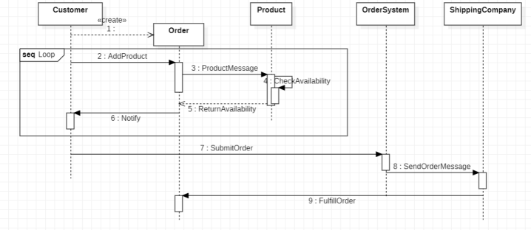 | Sequence Diagram in UML Modeling Report 11  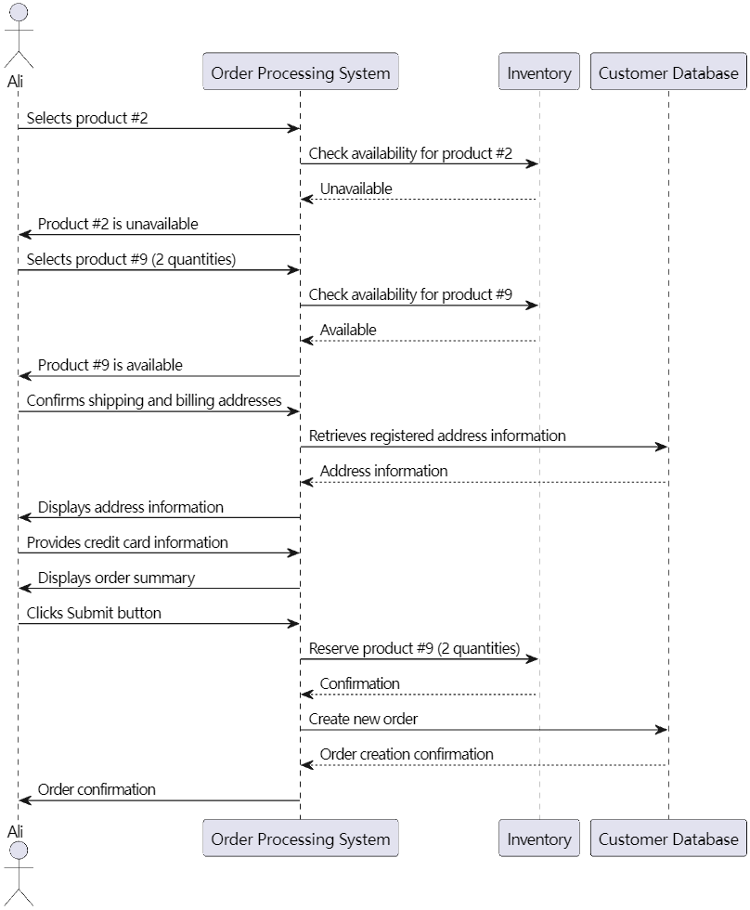
Sequence Diagram in UML Modeling Report 28  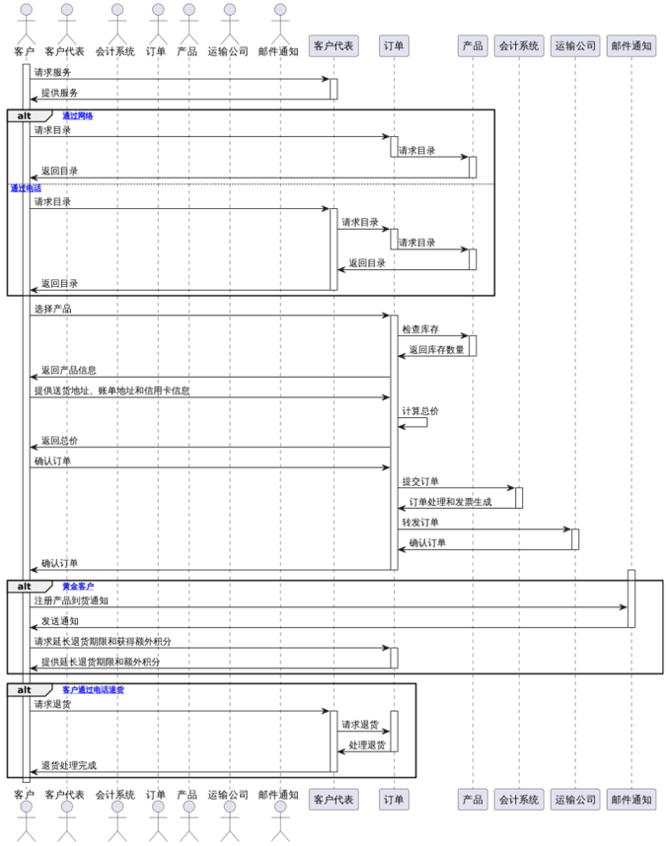 | Sequence Diagram in UML Modeling Report 30  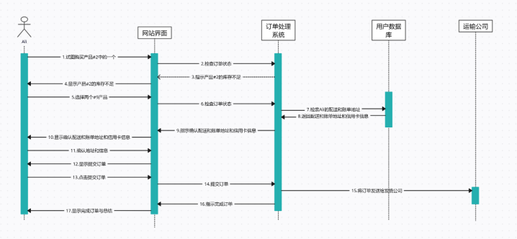
Sequence Diagram in UML Modeling Report 31  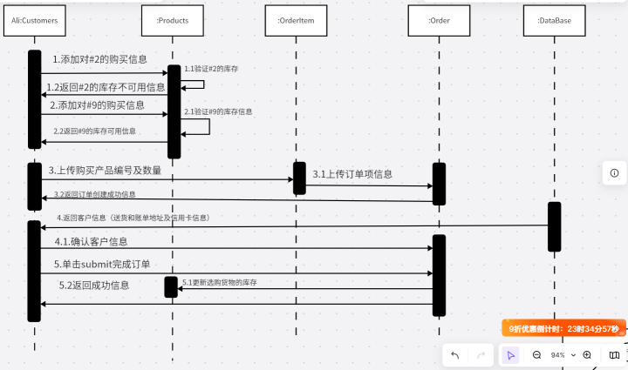 | Sequence Diagram in UML Modeling Report 35  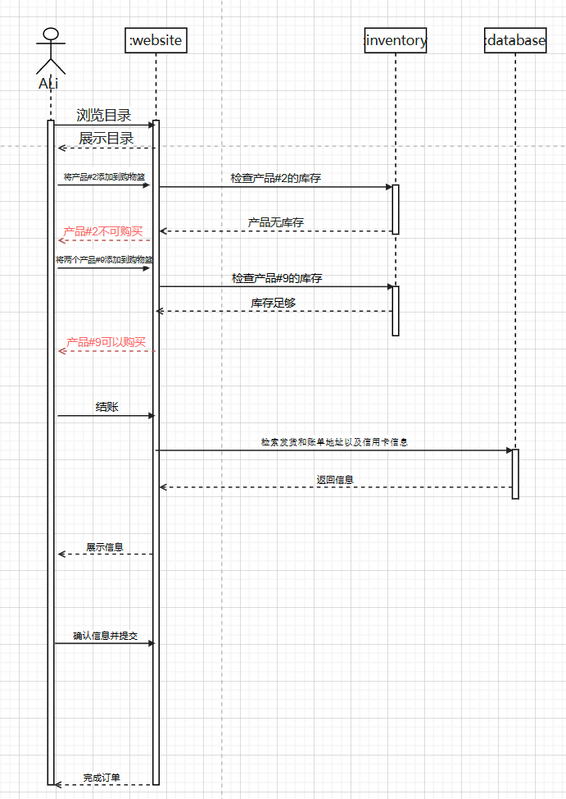

# | Origin of UML diagram | Human Experts (Score)/ GPT(Score) : Reasons (deducted points) | Type of discrepancy
SC1 | UML Modeling Report 28 | Human Expert (0.6): 识别出两个关键对象custom和会计系统(等同orderProcessedSystem) (-0.4) | Misunderstanding
SC1 | UML Modeling Report 28 | GPT (0.4): Missing essential object: PlaceOrderScreen (no UI/front-end object present).(-0.2); Missing essential object: OrderProcessingManager (no controller/manager object present).(-0.2); Missing essential object: InventoryManager (库存 is present, but as a data object, not as a manager/controller object).(-0.2) | Misunderstanding
SC1 | UML Modeling Report 30 | Human Expert (1.0): N/A | Wrong Identification
SC1 | UML Modeling Report 30 | GPT (0.6): Missing object: OrderProcessingManager (订单处理系统 is present, so no deduction).(-0.0); Missing object: PlaceOrderScreen (网站界面 is present, so no deduction).(-0.0); Missing object: InventoryManager (not present; 用户数据库 is not equivalent).(-0.2); Missing object: AccountingManager (not present).(-0.2) | Wrong Identification
SC1 | UML Modeling Report 31 | Human Expert (1): 这里我认为是四个,因为她这里的prodducts实际兼任了inventory这个对象;order实际上是orderProcessingManager这个类 (-0) | Reasonable Identification
SC1 | UML Modeling Report 31 | GPT (0.4): Missing essential object: PlaceOrderScreen is not present.(-0.2); Missing essential object: OrderProcessingManager (or equivalent) is not present.(-0.2); Missing essential object: AccountingManager (or equivalent) is not present.(-0.2) | Reasonable Identification
SC1 | UML Modeling Report 35 | Human Expert (1.0): N/A | Overtrictness
SC1 | UML Modeling Report 35 | GPT (0.4): Missing essential objects: 'OrderProcessingManager', 'AccountingManager', and 'PlaceOrderScreen'. Only 'website', 'inventory', and 'database' are present, which do not map directly to the required objects.(-0.6) | Overtrictness
SC2 | UML Modeling Report 1 | Human Expert (0.8): 缺少获取配送信息、账单生成的消息 (-0.2) | Reasonable Identification
SC2 | UML Modeling Report 1 | GPT (0.45): Missing message: No message between Customer and PlaceOrderScreen (OrderSystem is not a substitute for PlaceOrderScreen).(-0.1); Missing message: No message between PlaceOrderScreen and InventoryManager.(-0.1); Missing message: No message between PlaceOrderScreen and OrderProcessingManager.(-0.1); Ambiguous message names: 'ProductMessage', 'Notify', 'SendOrderMessage' are vague and do not clearly reflect their responsibilities.(-0.15); Unreasonable/ambiguous parameters: Messages do not specify product numbers, quantities, or other relevant parameters as per the scenario.(-0.1) | Reasonable Identification
SC2 | UML Modeling Report 11 | Human Expert (1.0): N/A | Misunderstanding
SC2 | UML Modeling Report 11 | GPT (0.75):Missing message: No message between Order Processing System and AccountingManager (or equivalent) for billing/creating invoice.(-0.1); Ambiguous message names: Some messages (e.g., 'Order confirmation', 'Confirmation') are vague and do not specify the operation performed.(-0.05); Missing message: No explicit message for creating the order in the system (should be a createOrder or similar).(-0.1) | Misunderstanding
SC2 | UML Modeling Report 28 | Human Expert (0.6): 缺少获取配送信息,生成账单扣0.2分(-0.2);消息全部无参数(-0.2) | Wrong Identification
SC2 | UML Modeling Report 28 | GPT (0.6): Missing essential messages between Customer and PlaceOrderScreen, PlaceOrderScreen and OrderProcessingManager, and OrderProcessingManager and InventoryManager (due to missing objects).(-0.3); Some message names are ambiguous or not clearly reflecting their responsibilities (e.g., '请求服务', '提供服务', '确认订单' are vague).(-0.1) | Wrong Identification
SC2 | UML Modeling Report 31 | Human Expert (0.95): 这里的消息,九号商品实际上是2个数量应该写上去(-0.05)) | Overstrictness
SC2 | UML Modeling Report 31 | GPT (0.7): Missing message: No message representing the interaction with an order processing manager/controller to coordinate the process.(-0.1); Missing message: No message representing the billing of the customer (interaction with accounting).(-0.1); Ambiguous message names: Some messages are not clearly named to reflect their purpose (e.g., '上传订单项信息', '返回客户信息'), which are vague compared to the reference.(-0.05); Missing parameters: Some messages lack clear parameters (e.g., product ID, quantity, shipping info), which are explicit in the reference.(-0.05) | Overstrictness
SC3 | UML Modeling Report 1 | Human Expert (0.8): 订单提交与发货消息顺序基本合理，但缺少账单生成等后续流程，整体流程与案例描述有一定偏差。(-0.2) | Reasonable Identification
SC3 | UML Modeling Report 1 | GPT (0.6): Order of messages does not follow the scenario: e.g., confirmation of shipping/billing info and credit card is missing before order submission.(-0.2); Significant deviation from the described process: e.g., missing steps for inventory check for each product and confirmation before submission.(-0.2) | Reasonable Identification
SC3 | UML Modeling Report 11 | Human Expert (1.0): N/A | Misunderstanding
SC3 | UML Modeling Report 11 | GPT (0.8): Order of messages: The sequence does not show the billing/invoice step after order creation, which is a required part of the process.(-0.2) | Misunderstanding
SC3 | UML Modeling Report 28 | Human Expert (0.6): 整体流程与案例描述不符,根本不看案例(-0.4) | Wrong Identification
SC3 | UML Modeling Report 28 | GPT (0.8): The order of messages does not strictly follow the scenario: the process is mixed with return product and notification logic, which is not part of the main 'place order' scenario; also, the sequence of checking inventory, confirming shipping info, and submitting order is not clearly separated.(-0.2) | Wrong Identification
SC3 | UML Modeling Report 30 | Human Expert (0.8): 并不是直接选择9号商品之后就直接检查订单状态了,中间缺了流程(-0.2) | Perfect Match
SC3 | UML Modeling Report 30 | GPT (0.8):Order of messages: The sequence omits the explicit inventory check and billing steps, which are essential to the scenario.(-0.2) | Perfect Match
SC3 | UML Modeling Report 35 | Human Expert (0.7): 消息顺序不太合理,应先下订单才会付款,而且确认信息提交应该在付款之前(-0.3) | Overstrictness
SC3 | UML Modeling Report 35 | GPT (0.6): The sequence of messages omits key steps (e.g., order creation, billing, invoice generation), and the overall order deviates from the described scenario.(-0.4) | Overstrictness

